**Step 1**

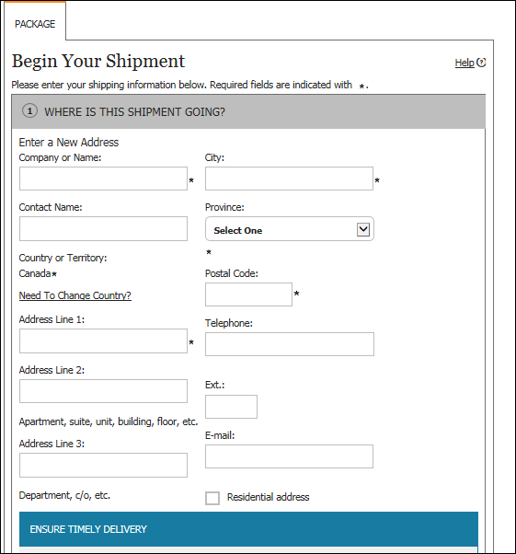

Where are you sending?

**Step 2**

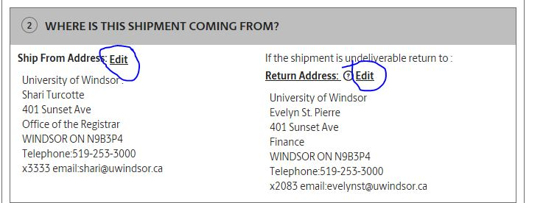

**Step 3**

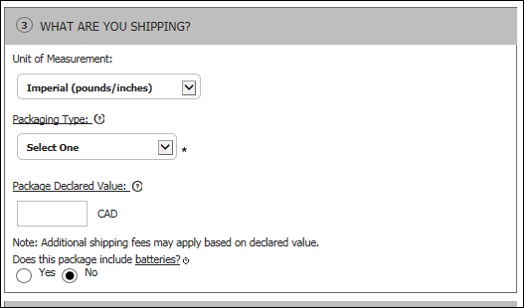

UPS Express Envelope

If very important

**Step 4**

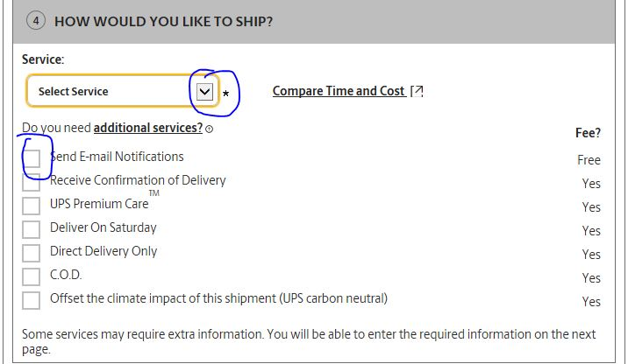

**Step 5**

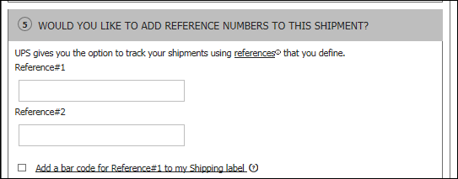

Your department account number/name

**Step 6**

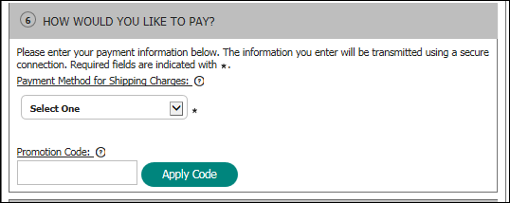

Please do not touch

**Step 7**

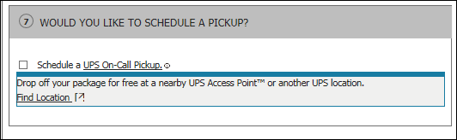

Please do not touch – Pick up from Distribution Services